Discrete-Time Signals and Systems

Project 1

Gaurav Shilpakar R11521961

Raju Khadka R11536576

October 2019

Question 1

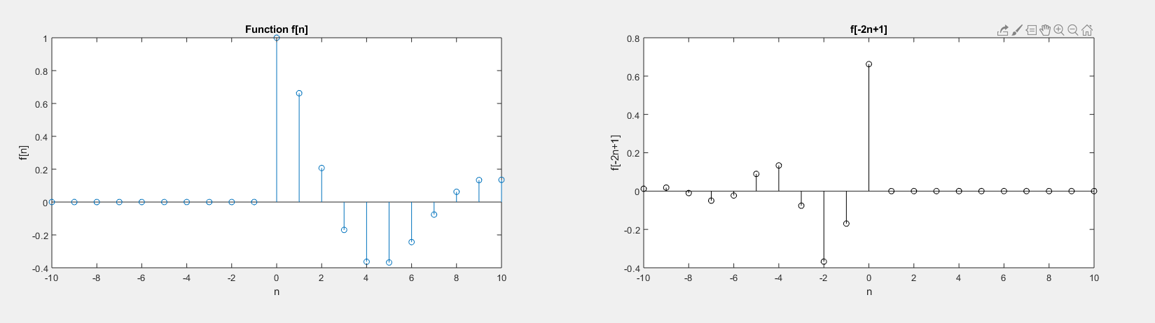

Figure 1

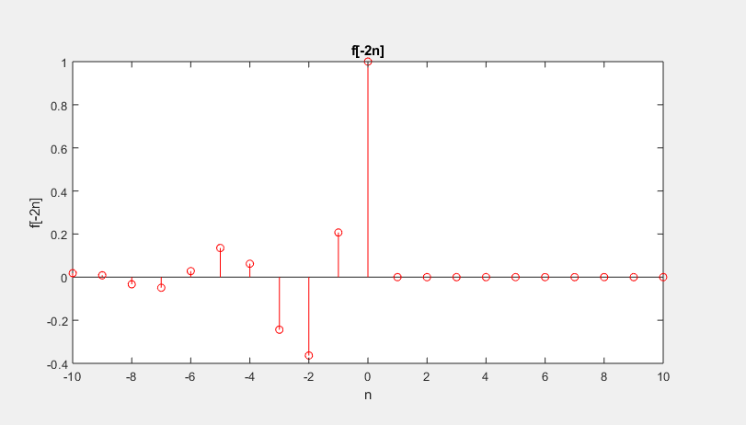

Figure 2

Figure 3

Part 1

The given discrete time signal was as below:

$$f\left[n\right]= e^{{-n}/5}\cos\left({πn}/5\right)u[n]$$

The function was created using the *inline* function. Then it was plotted in a range of -10 to 10 using the *stem* command in MATLAB. The output received was as in fig 1. Similarly, the same function was modified to plot functions for f[-2n] and f[-2n+1]. The plots are shown in fig 2 and 3 respectively.

Part 2

The next system was defined as $y[n] – y[n-1] + y[n-2] = x[n]$.

The given system was plotted for the range of 0 to 30. The function was divided into coefficients of x and y as a and b respectively. The delta function was defined as delta[n]=0 for n=0. And then the function was realized as *filter* function of a, b and delta. It was plotted using *stem* function. Also, the plot for BIBO stability was given by the *z-plane* function.

The system has two roots defined as

$$x1=\frac{1}{2}+j\frac{\sqrt{3}}{2} and x2=\frac{1}{2}-j\frac{\sqrt{3}}{2}$$

Since these roots are unique and lie on the unit circle, the given system is Marginally Stable but BIBO Unstable.

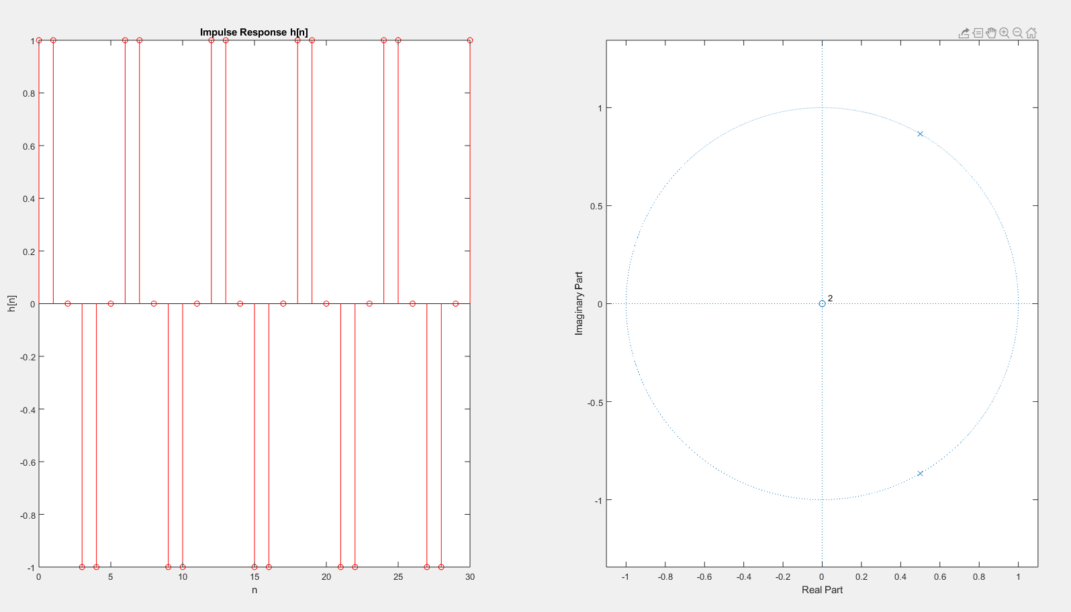

Figure 4

Similarly, the input $x\left[n\right]= \cos\left({2πn}/6\right)u[n]$ was passed into x using the *inline* function. Then, the zero-state response was plotted using filter of a, b and x[n]. For, the zero-input response, the initial conditions of $y[-1] = 1 and y[-2] = 2$ was passed using *filtic* function. The final output is given as follows:

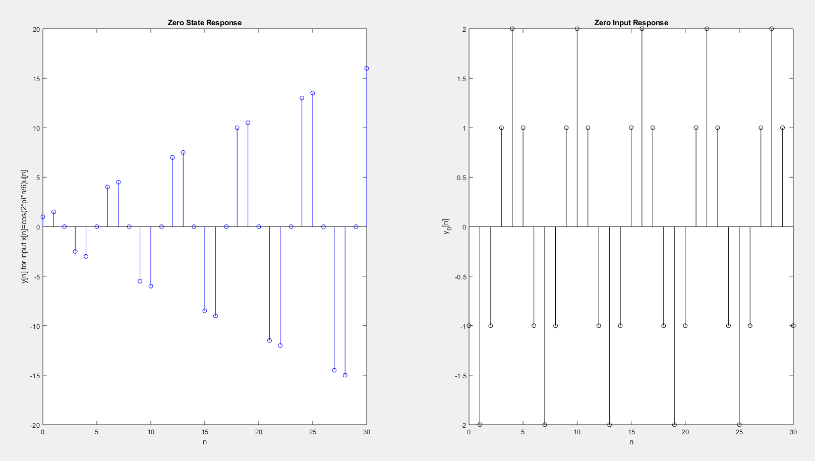

Figure 5

Part 3

The given impulse response is $h\left[n\right]= \left\{\cos\left({πn}/3\right)+ \frac{1}{\sqrt{3}} \sin\left({πn}/3\right)\right\}u[n]$. The input for the response is given by $x\left[n\right]= \cos\left({2πn}/6\right)u[n].$ These equations were initialized using the *inline* function. Then the required zero state response y[n] was realized by the convolution of h and x given by the *conv* function. The final plot was given by *stem* for a range of 0 to 30*.*

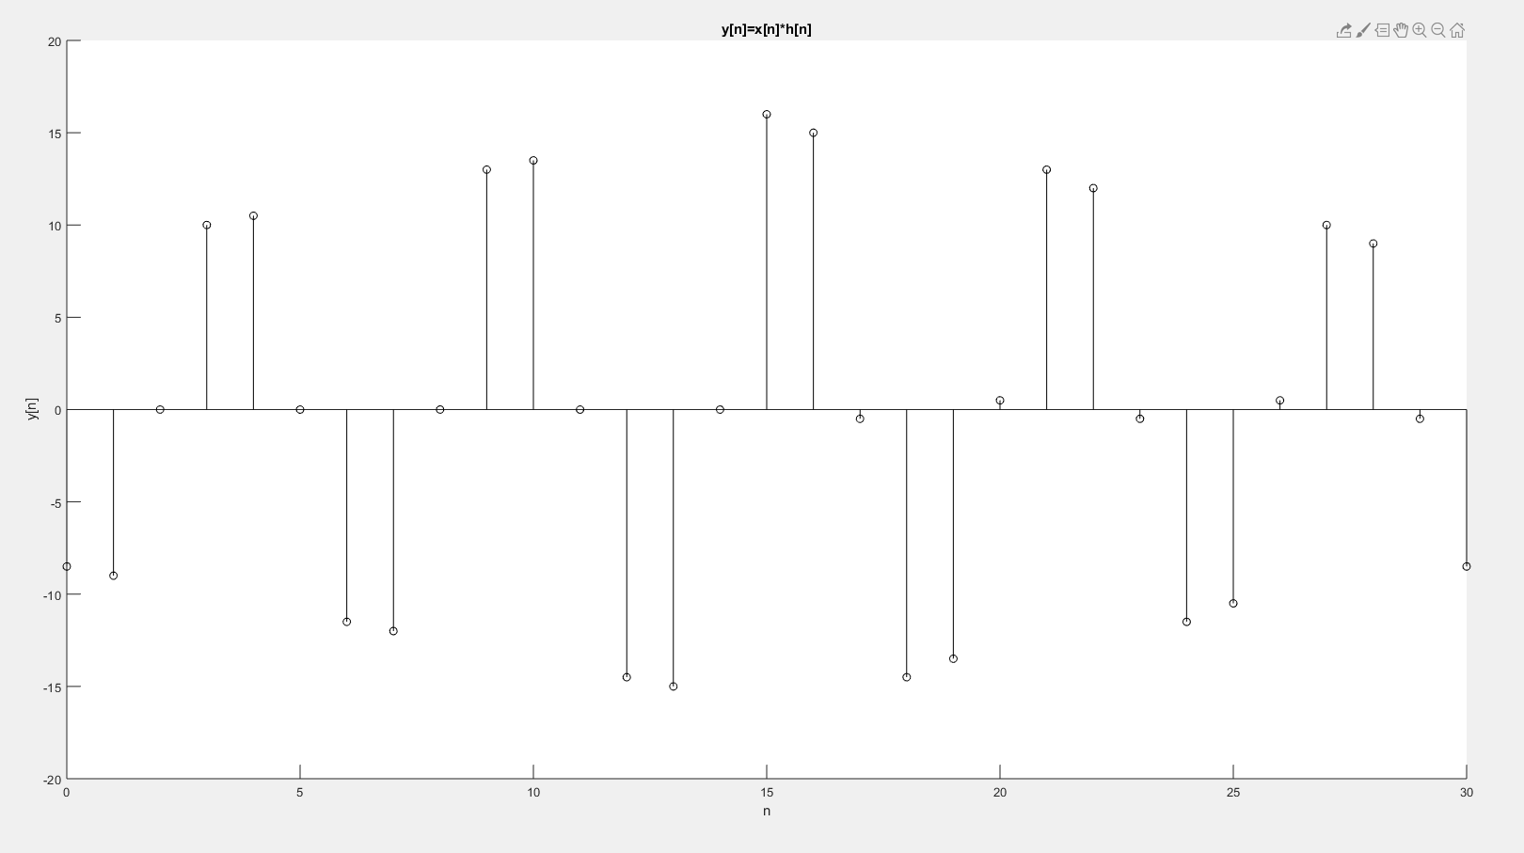

Figure 5

Part 2

1. Express rxy[k] in terms of convolution. Is rxy[k] = ryx[k]?

$$rxy\left[k\right]=x\left[n\right]*y\left[n\right]=\sum_{n=-∞}^{∞}{x\left[n\right].y\left[n-k\right]}$$ No, rxy[k] != ryx[k]

But, rxy[k] = ryx[-k]

1. Cross-correlation refers to the measure of similarity of two systems or signals as a function of displacement of one relative to the other. For signals x[n] and y[n], the cross-correlation is equivalent to the convolution between them. Such convolution defines how the form of one signal is affected by the cause of the other signal.

r = x[n] * y[n]

Such a function gives information about the similarity between the signals.

1. The required function was initialized with four-vectors (x, y, nx, and ny) under the name p2_1. Here, x and y are the given discrete time signals, nx and ny are the ranges of x and y respectively. The shift vector k was also initialized. The range was given by the range received from the *conv* of the systems x and y. Then the shift ranges from 0 to 50 as per the output rxy. The signals x[n] and y[n] are initialized using *stem* function and then plotted individually.

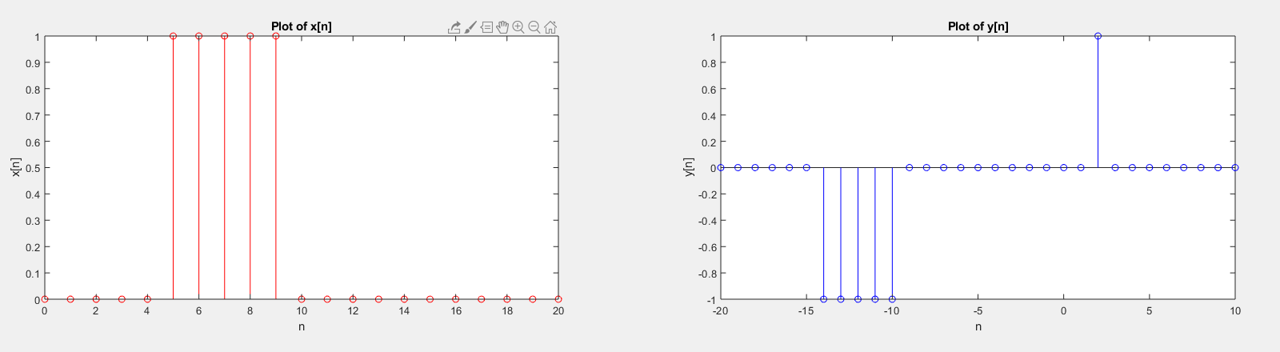

Figure 6

The aforementioned function was used to find the convolution between these signals.

As per the output, the largest magnitude seen was 5 at k = 29.

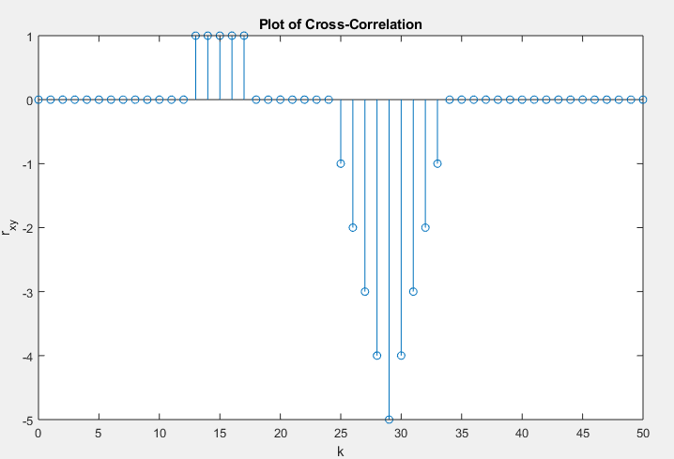

Figure 7